Ocean Data Analysis and Presentation (ODAP) Syllabus
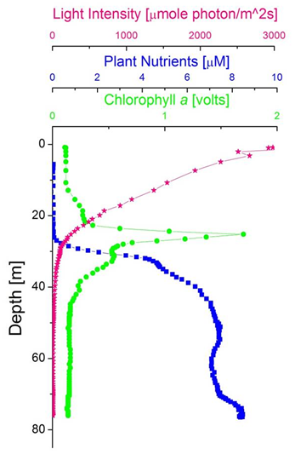
(Course number here)

PROFESSOR: Dr. Robert Vaillancourt, Office: Brossman 106, Tel: (717) 871-4190, email: Robert.vaillancourt@millersville.edu

COURSE TEXT (suggested): How to Write and Publish a Scientific Paper, 6th Ed., 2006. Day, R.A., and B. Gastel, Greenwood Press, Westport, CT., 302 pp. Also, some outside readings may be assigned to support the lecture material. These articles will be either made available to you as PDF files posted to the D2L website, as photocopies in class, or as library reserves.

LECTURE TIMES/PLACE: Mondays and Wednesdays, 1:00 – 2:50 pm, Caputo 400.

COMMUNICATION AND INTERACTIVITY: Please refer to D2L site for course material and discussions. Please use your MyVille email account for correspondence with me.

COURSE DESCRIPTION: Advanced ocean science course covering the theory and practice of some of the more common techniques of ocean sampling, analysis, and presentation of oceanographic data. We will review the meaning of data and the common types of oceanographic data, methods of ocean data collection, the meaning and importance of metadata, databases, database management, and their importance in environmental research, the idea of geospatial data and the importance of frame of reference and time and space scales of interest, the variety of ways to analyze and present oceanographic data, and how to present data to maximize its informational content.

COURSE OBJECTIVES:
- Using weekly problem set you will learn methods commonly used in the ocean sciences to quality check, explore, and analyze marine science data.
- You will understand the breadth of different types of ocean data and the meaning and importance of metadata in database management.
- You will search and retrieve oceanographic data from ocean databases and analyze data towards testing a scientific hypothesis.
- You will communicate the results of your data analysis as a written scientific research article, oral presentations, and poster presentation.
- You will learn and apply appropriate graphing and presentation methods to best convey scientific information to an audience of your science peers and to a general audience.
COURSE POLICIES
How to earn an ‘A’ in this class: Students will excel in this course if they complete all the requirements in a timely, thoughtful manner and achieve a numerical grade of at least 90%. The final course letter grade is determined as follows:

Class participation & attendance | 10
Data analysis project – 2 oral presentations | 15
Data analysis project – written assignment | 15
Data analysis project – poster at MiM | 15
Weekly problem sets | 45
TOTAL | 100
Scaling of letter grade to numerical grade: <60% = F; 60-69% = D; 70-79%=C; 80-89% =B; 90-100%=A. Plusses and minuses awarded on ends of ranges for letter grades A thru D.
TITLE IX
Millersville University and its faculty are committed to assuring a safe and productive educational environment for all students. In order to meet this commitment, comply with Title IX of the Education Amendments of 1972, 20 U.S.C. §1681, et seq., and act in accordance with guidance from the Office for Civil Rights, the University requires faculty members to report to the University’s Title IX Coordinator incidents of sexual violence shared by students. The only exceptions to the faculty member’s reporting obligation are when incidents of sexual violence are communicated by a student during a classroom discussion, in a writing assignment for a class, or as part of a University-approved research project. Faculty members are obligated to report to the person designated in the University Protection of Minors policy incidents of sexual violence or any other abuse of a student who was, or is, a child (a person under 18 years of age) when the abuse allegedly occurred.

Information regarding the reporting of sexual violence, and the resources that are available to victims of sexual violence, is available at http://www.millersville.edu/socialeq/title-ix-sexual-misconduct/index.php.

PHYSICAL OR LEARNING DISABILITIES
If one has a documented physical or learning disability and is entitled to special accommodations, please inform the professor.
See: http://www.millersville.edu/learningservices/disabilityaccom.php, for information
on such accommodations.

